Alteryx Workflow – IMDB Staging Tables

stg_imdb_title_crew

stg_imdb_title_crew_director

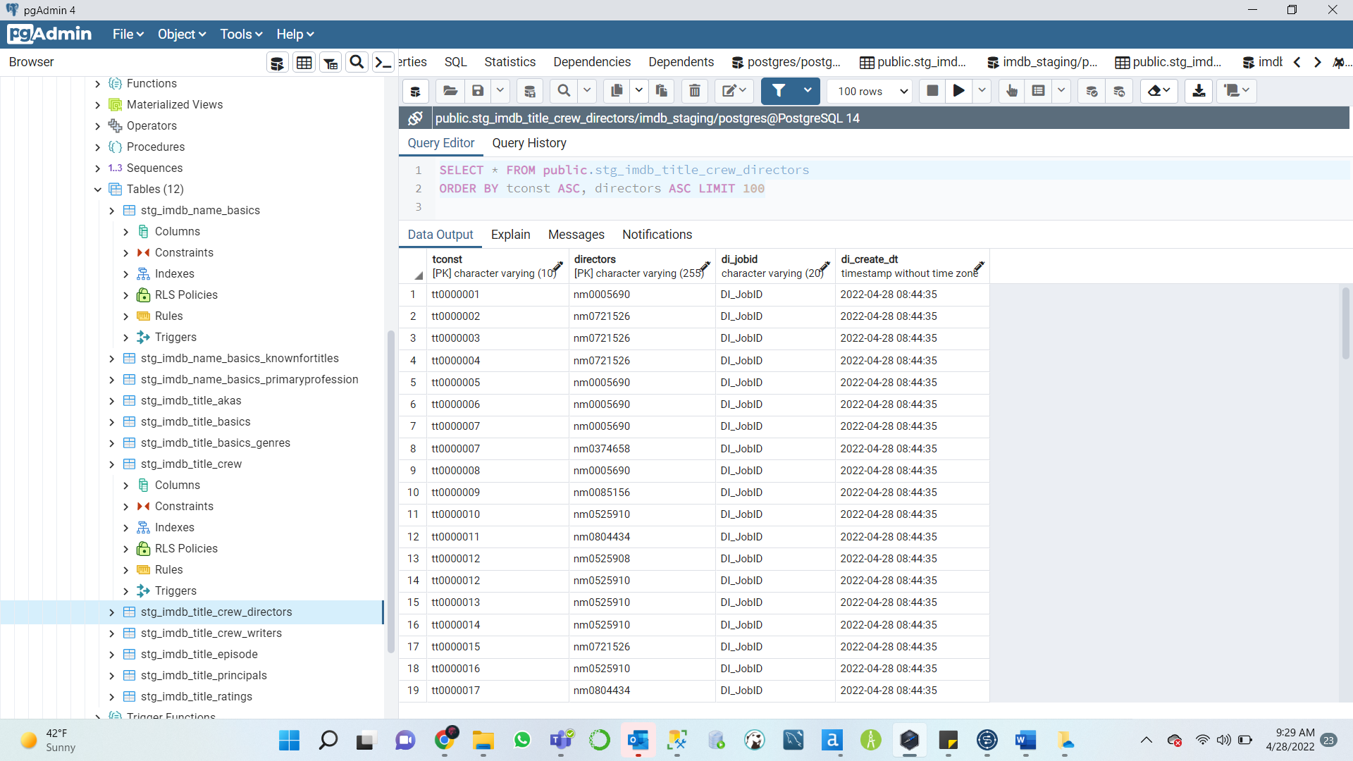

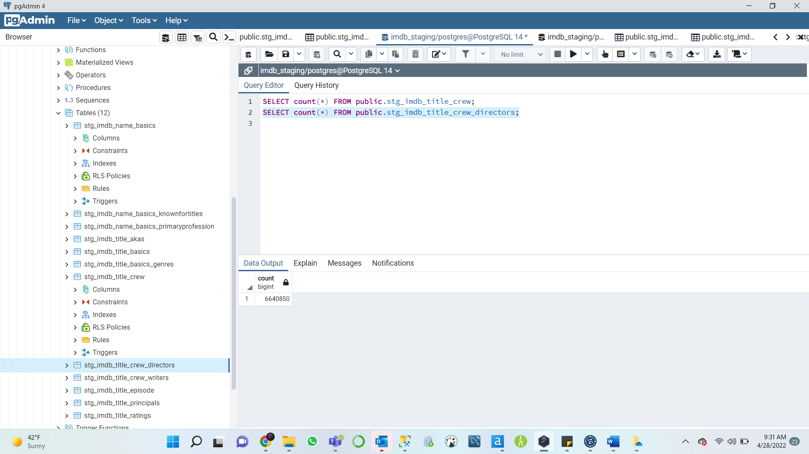

stg_imdb_title_crew_writers

stg_imdb_title_principles

stg_imdb_title_akas

stg_imdb_title_episode

stg_imdb_name_basics

stg_imdb_title_ratings

